**Test Report**

**Language used:** Python

**Test Library used:** unittest

**IDE used:** PyCharm

**Test Cases:** 5

There are two files that are given below:

1. main.py
2. test_code.py

main.py is the code file that is required to test. This is written by me specifically for this assignment.

test_code.py is the testing code file that will test the main.py by using unittest.

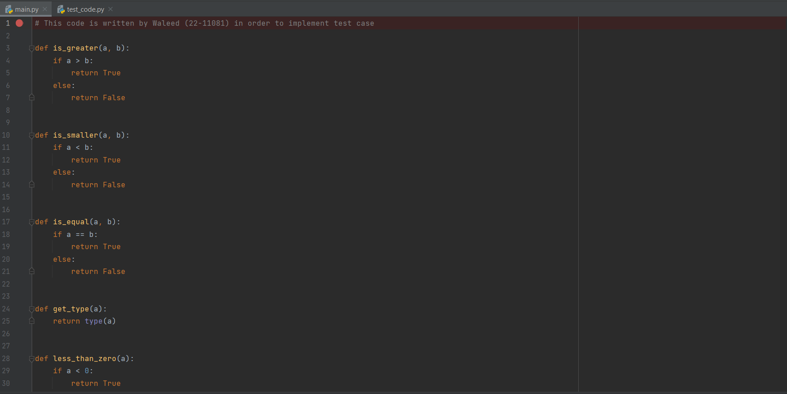

**main.py code screenshot**

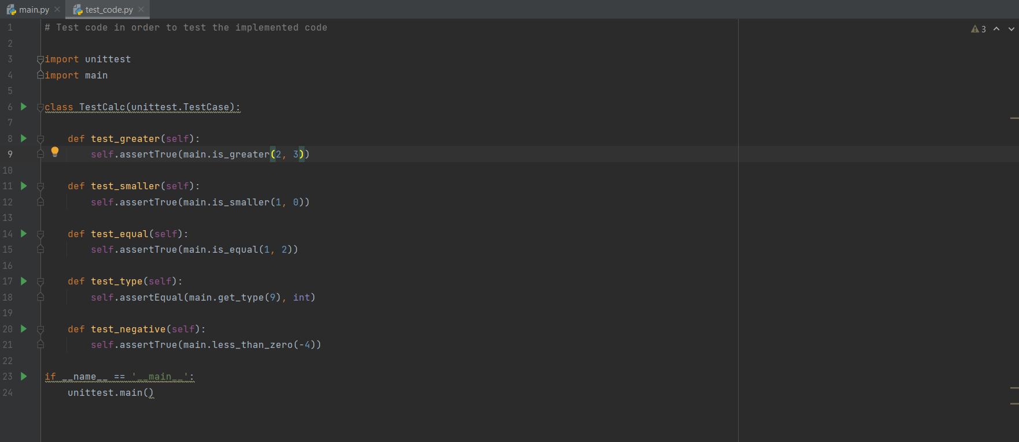

**test_code.py code screenshot**

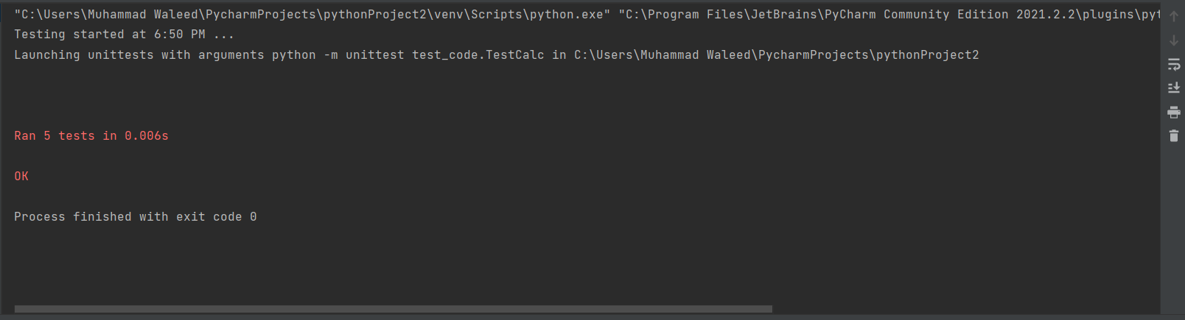

**Testing with correct cases screenshot**

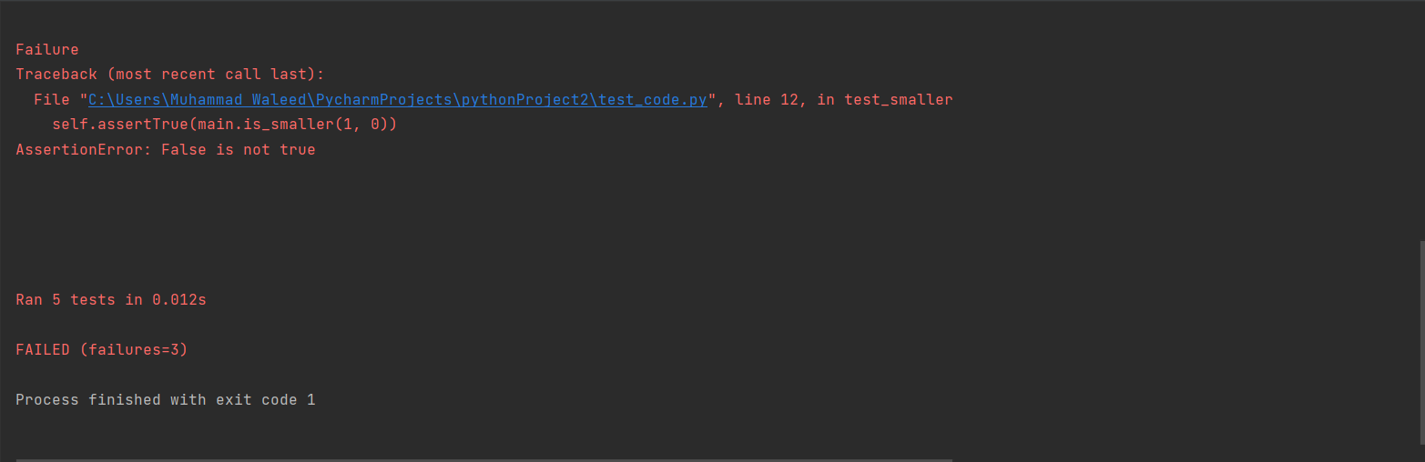

**Testing with wrong cases screenshot**